***William Percy’s Group of Handwriting Variants***

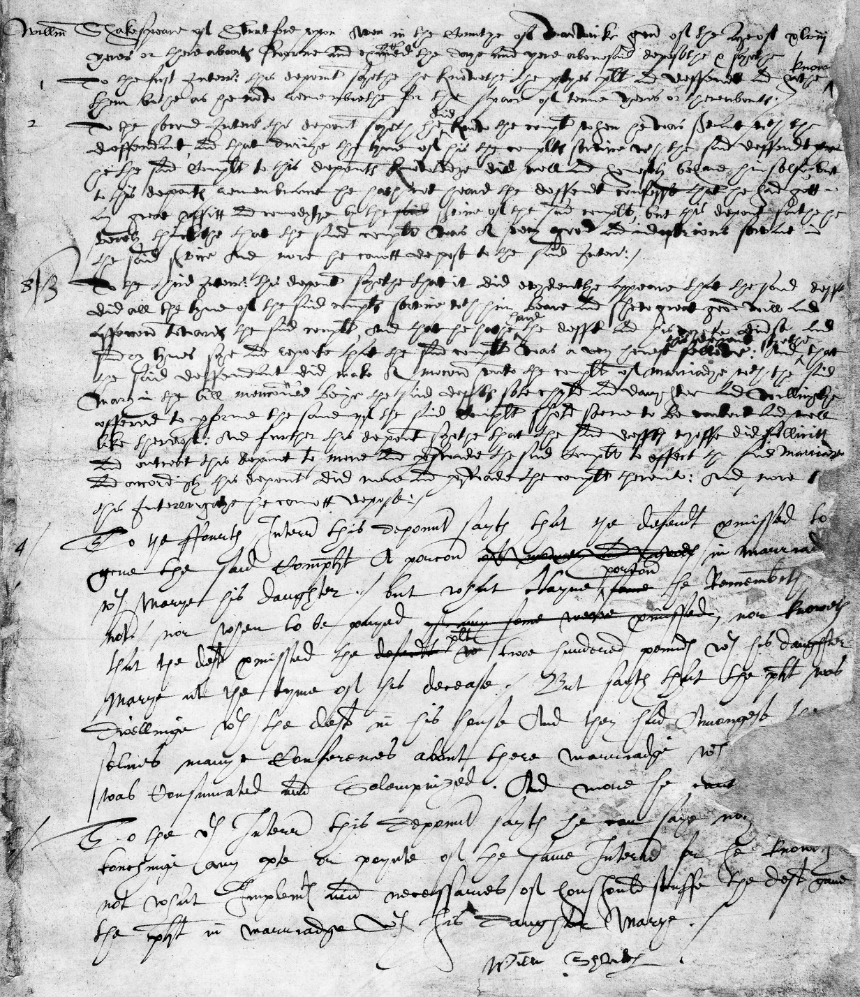

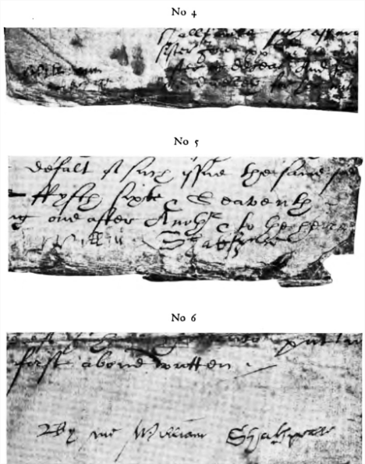

Three Legal Documents with “Shakespeare” Signatures (Maunde)

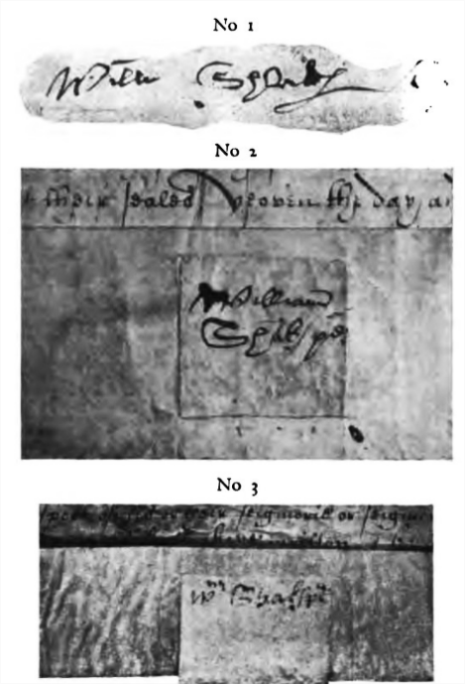

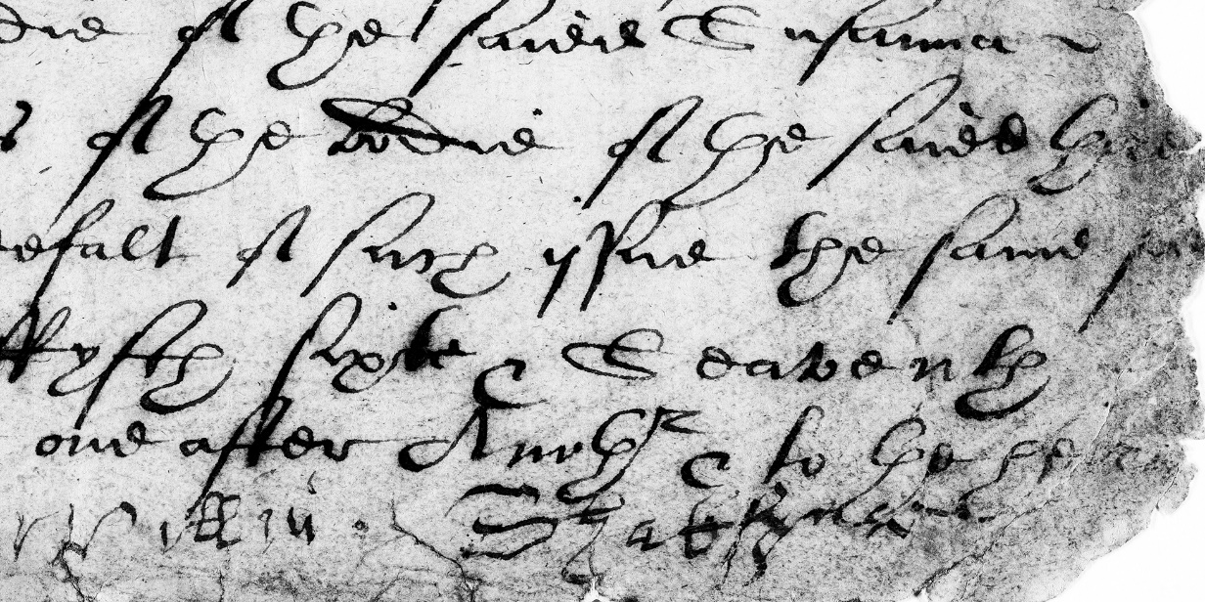

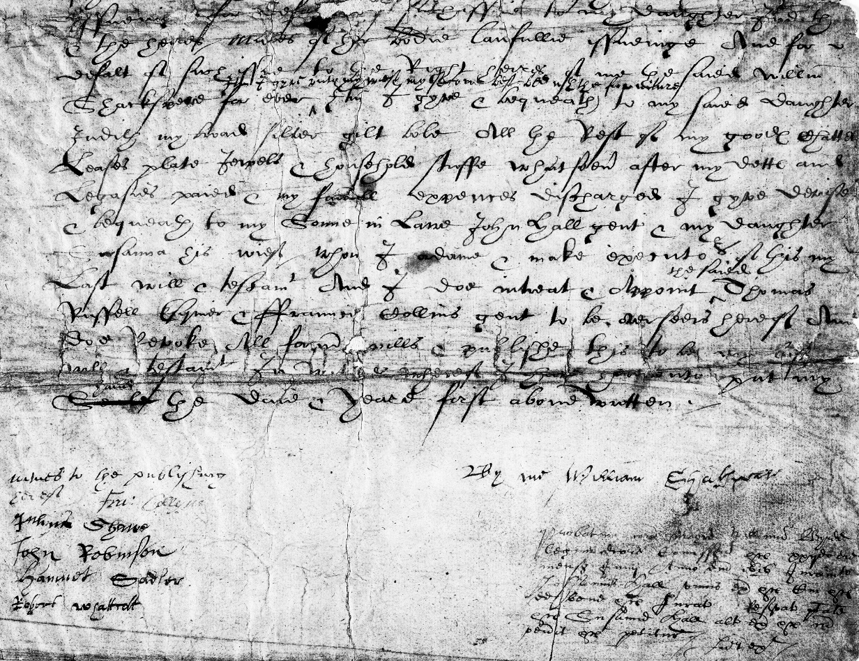

“Shakespeare’s” Will Signatures (Maunde)

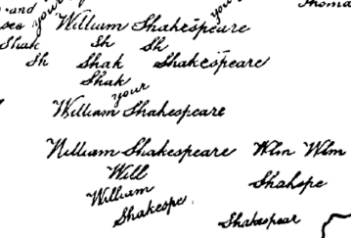

*Northumberland MS*: “Shakespeare” Handwriting Exercises

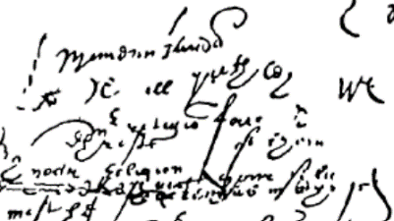

*Northumberland MS*: Scribbles

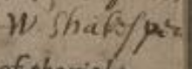

“Shakespeare’s” name in annotation on “Greene’s” *Pleasant Conceited Comedy*

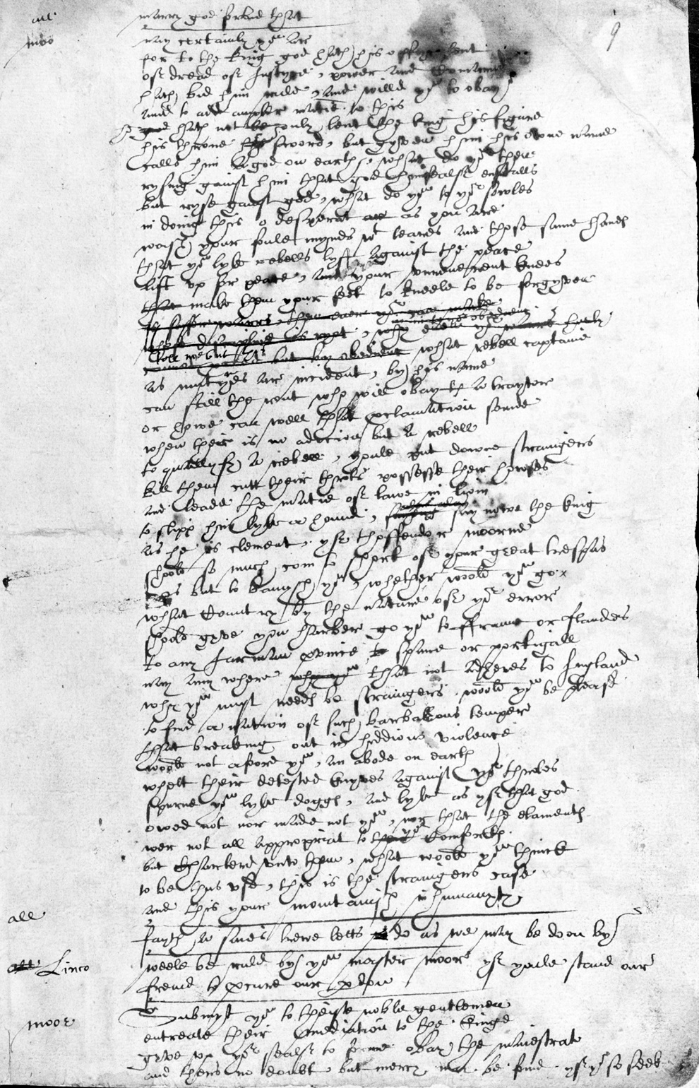

“*The Book of Sir Thomas Moore*: Shakespeare’s Handwriting in the *Harley MS 7368*, folio page 9r.” (British Library, 1601-4).

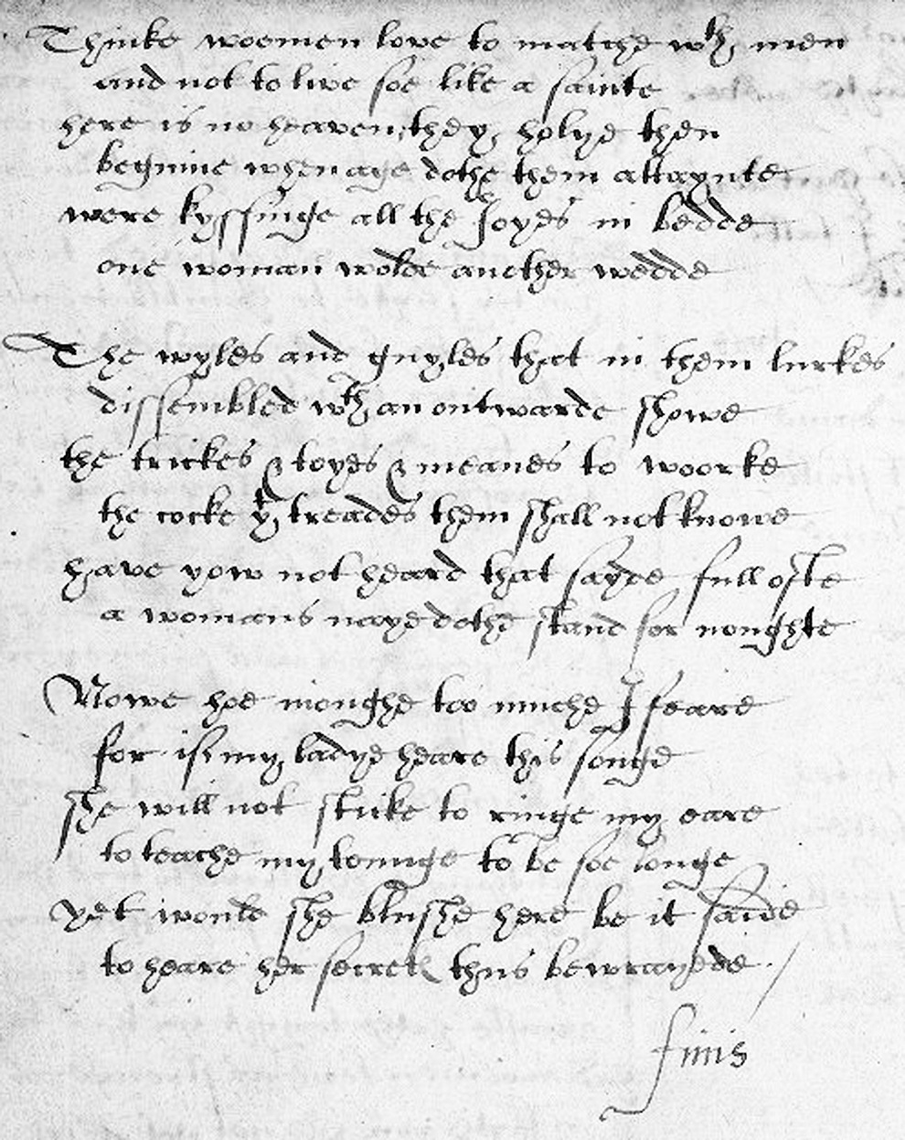

“Anne Cornwallis’ Poetical Miscellany with an Early Apocryphal Poem by Shakespeare”, V.a.89, page 26 (Washington DC: Folger Shakespeare Library, 1590/1600?).

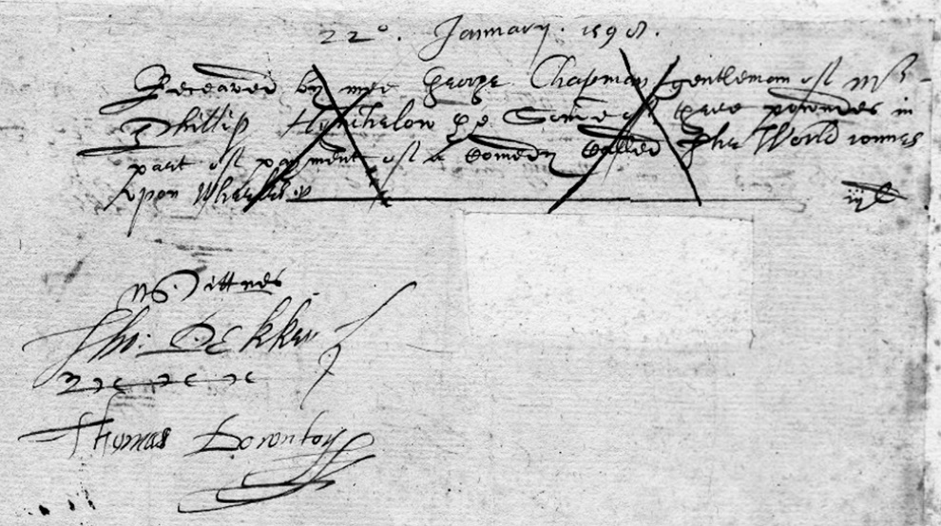

“Cancelled Receipt by George Chapman, gent., of a £3 loan from Philip Hynchelow in part payment of a comedy, *The World Runs upon Wheels*, January 22, 1599. Witnessed by Thomas Dekker and Thomas Downton” (Folger Shakespeare Library).

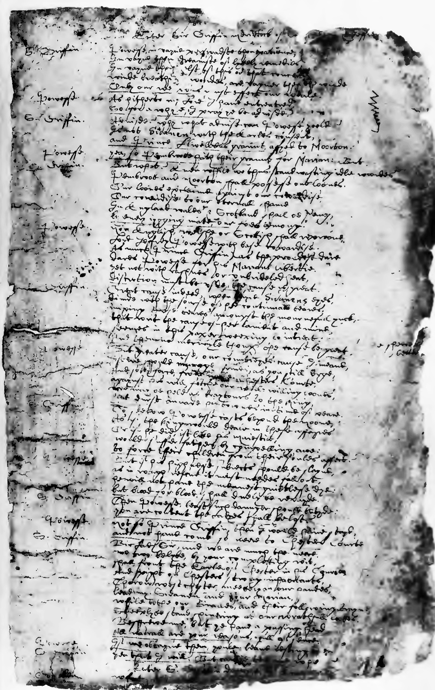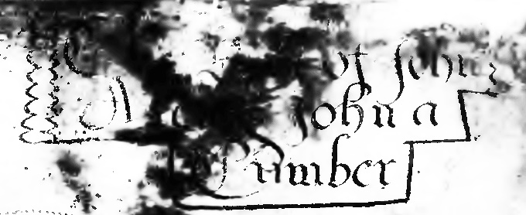

*John-a-Kent and John-a-Cumber* manuscript in “Munday’s autograph” (December 1595; reprinted in facsimile in John S. Farmer’s *The Tudor Facsimile Texts*: 1912).

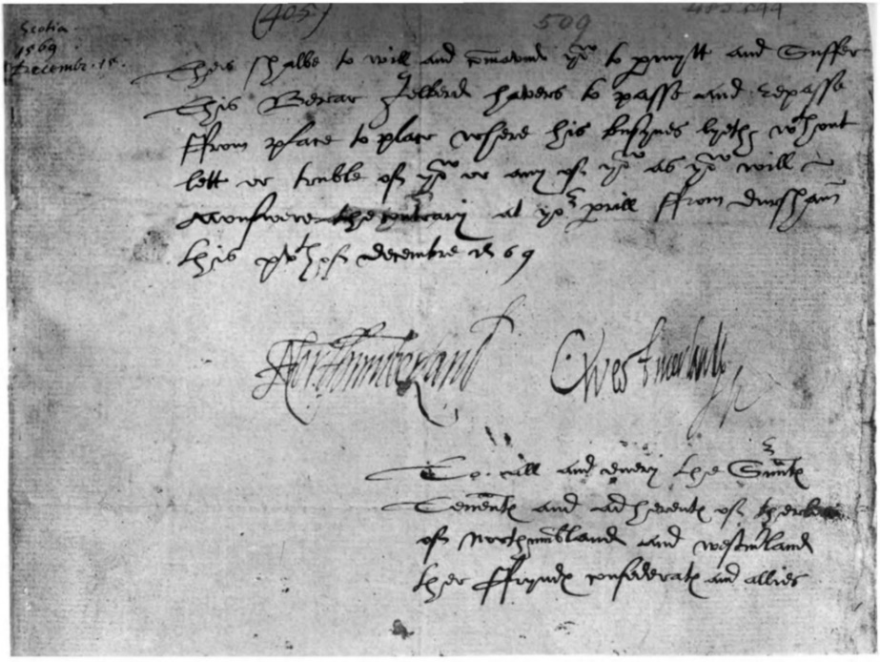

“Facsimile of Passport Signed by Thomas Seventh Earl of Northumberland [1528-72], and the Earl of Westmoreland [1542-1601]”: *AHP*.

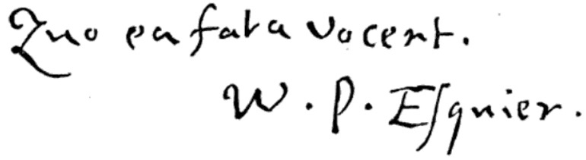

William Percy’s Signature on the Title-Page of His Self-Attributed Manuscripts (*HEDP*).

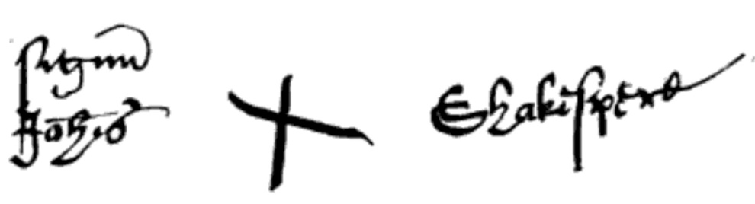

“Johannem Shakespe’s” Signature on “A Deed of Conveyance, from John Shakespeare to George Badger, of a slip of land belonging to the Birth-Place estate, January 1596-7” (*Outlines of the Life of Shakespeare*, Volume 2).

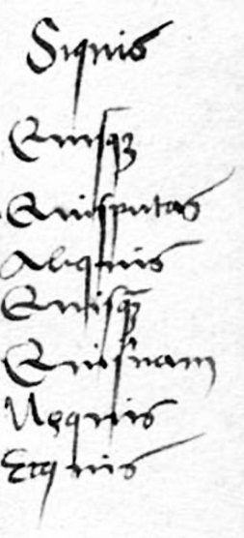

Potentially Percy’s Handwriting on the Quoted Alexander Brassicanus’ *Istitutiones Grammaticae* (1516?).

***Josuah Sylvester’s Group of Handwriting Variants***

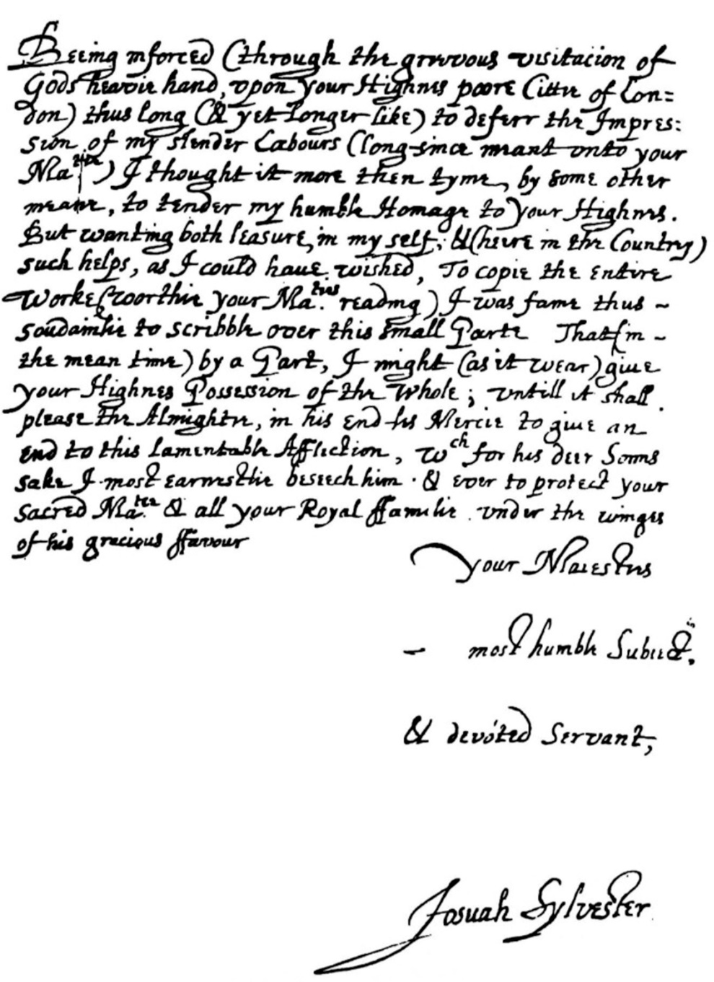

Josuah Sylvester’s Dedication Letter to James I from the 1603 edition of *Du Bartas.* From: *English Literature: An Illustrated Record*.

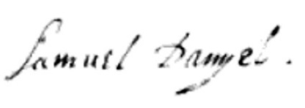

“Samuel Daniel’s” signature from the MS. Copy of *Panegyric Congratulatory to King James* (Royal MSS. XVIII, A. 72). From: *Autographs*.

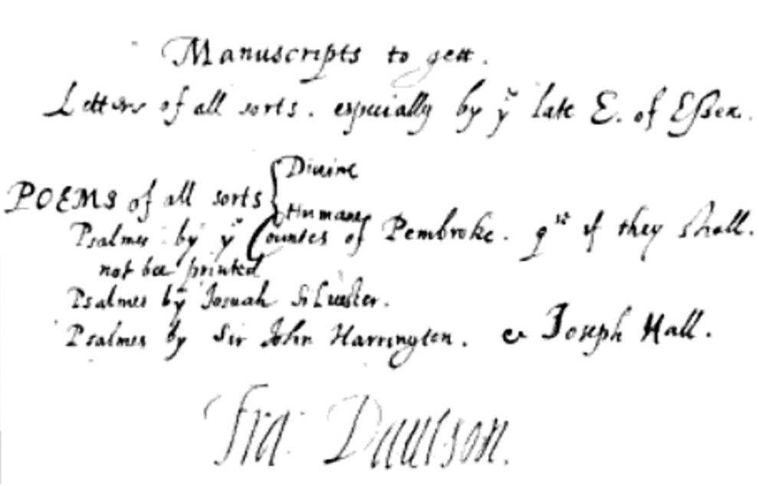

“Francis Davison’s” autograph from Harl. MSS. 298, fol. 157, b. with planned pieces for the forthcoming *Poetical Rhapsody*: “His Signature is added from another authority.” From: *Autographs*.

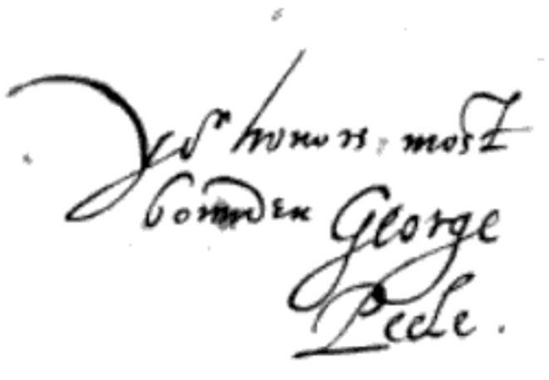

“George Peele’s” signature from a letter to “Lord Burleigh” in the Lansdowne MSS. 99, fol. 54. From: *Autographs*.

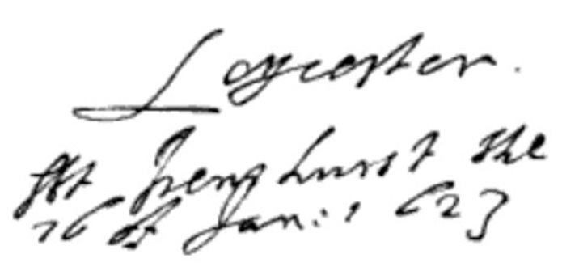

“Robert Sidney’s” Handwriting: “At Penshurst, the 16 of Jan. 1623”. *Harl. MSS. 7000, fol. 72*, as printed in *Autographs*.

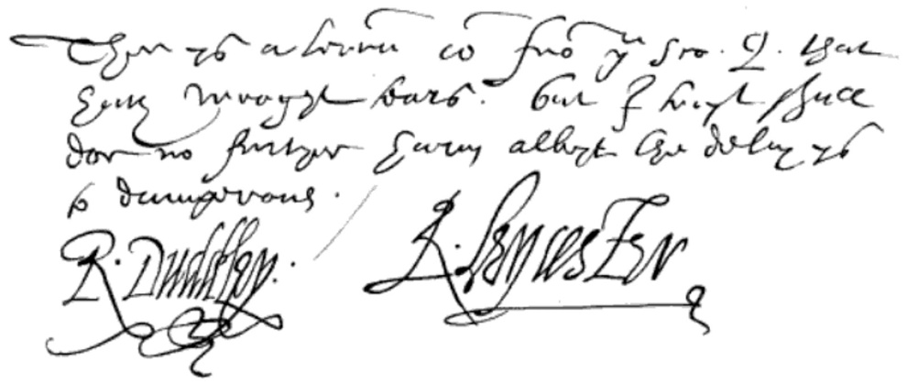

“Robert Dudley, Earl of Leicester’s” Handwriting: “There is a letter come from you Sco. Q. that has wrought tears; but I trust shall do no further harm, albeit the delay is too dangerous.” From a letter to Walsingham. *Harl. MSS. 285, fol. 268*, as printed in *Autographs*.

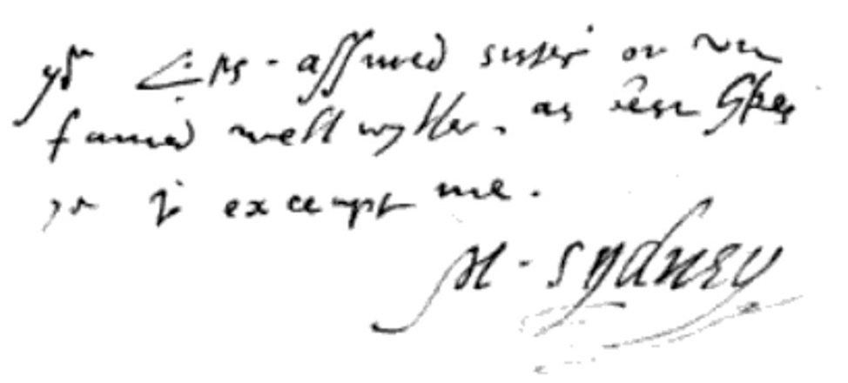

“Mary Sidney’s” Handwriting: “Your L’p’s assured sister, or unfeigned well wither, as best likes you to accept me, M. Sydney”. From a letter to Mary Sidney’s brother-in-law, Earl of Sussex, in Cotton. *MSS. Titus, B. 11. Fol. 305*, as printed in *Autographs*.

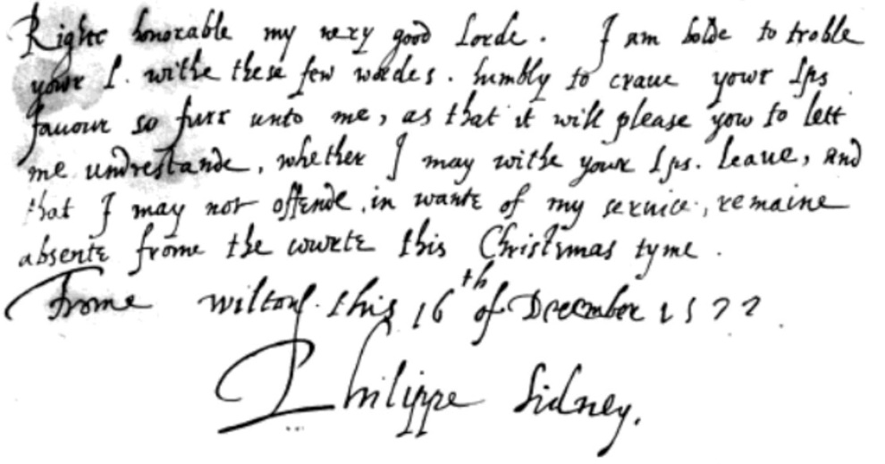

“Sir Philip Sidney’s” Handwriting: “Right honorable my very good Lord, I am bold to trouble your L. with these few words, humbly to crave your Lordship’s favor so far unto me, as that it will please you to let me understand, whether I may, with your Lordship’s leave, and that I may not offend in want of my service, remain absent from the court this Christmas time. From Wilton, this 16th of December, 1572. Philippe Sidney.” From a letter to Philip’s uncle, Earl of Leicester. *Harl MSS. 6992, fol. 42*, as printed in *Autographs*.

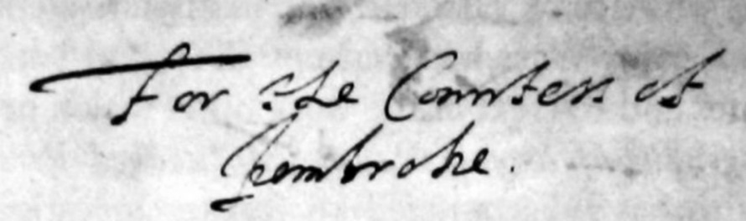

“Robert Sidney’s” autograph inscription, “For the Countess of Pembroke”, on the initial leaf (fol. I) of *MS. 58435* (British Library).[1]

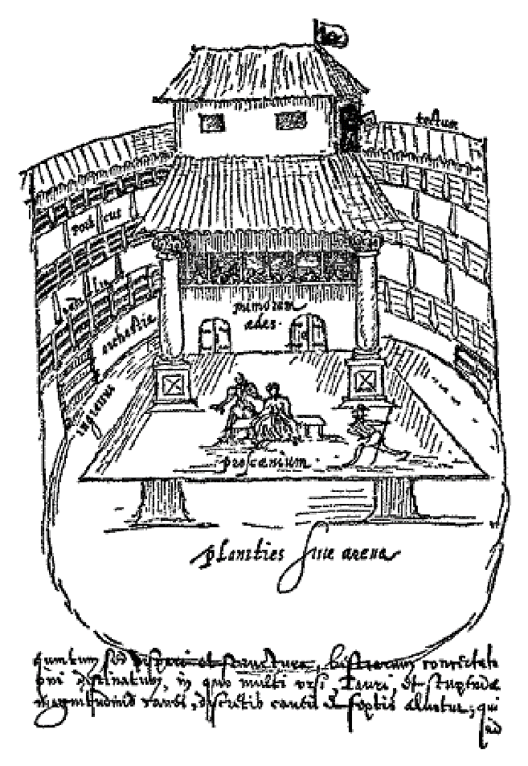

Interior of the Swan Playhouse: Sketched by “Johannes de Witt” in 1596 (*SP*).

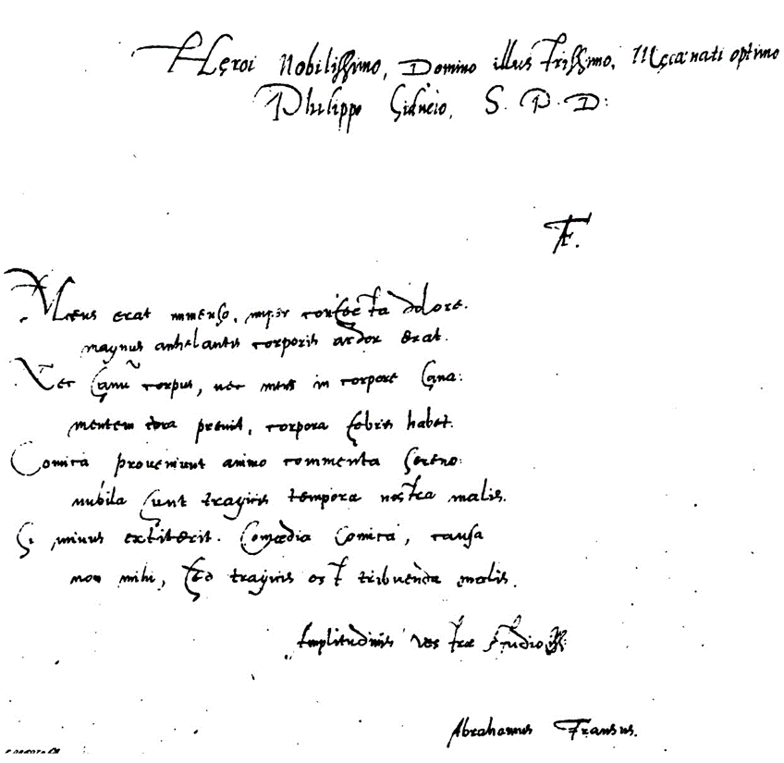

“Abrahamus Fransus” Autograph Dedication on *Victoria* in the *Penshurst MS* (From Smith’s Facsimile).

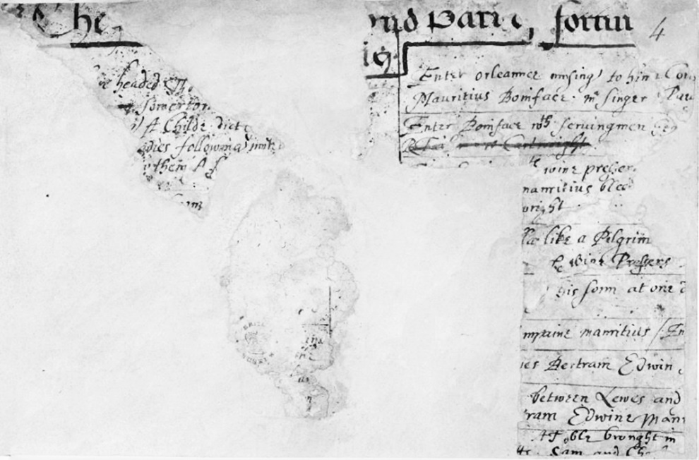

“*The Second Part of Fortune’s Tennis* (fragmentary)”, *Add MS 10449*, f. 4r (British Library, 1600-3?).

***Gabriel Harvey’s Group of Handwriting Variants***

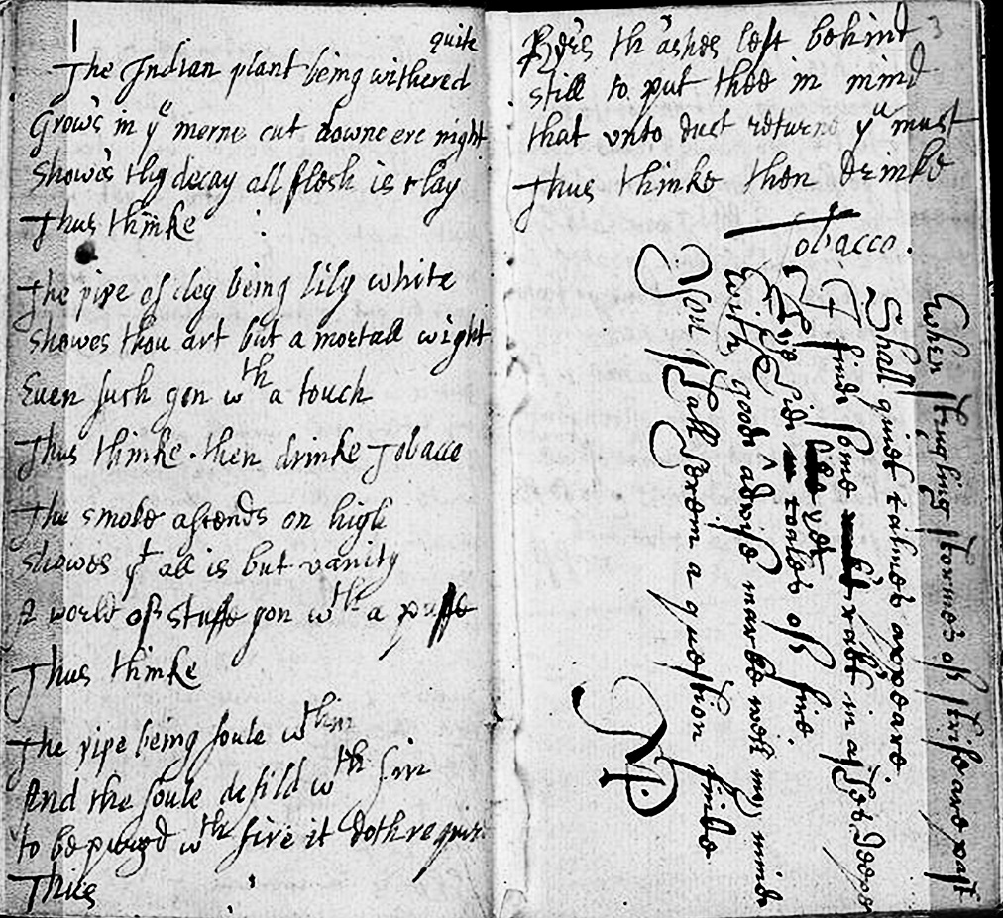

Anonymous Commonplace Poetry Book Collection, includes the likely Harvey-handwriting in “The Indian Plant Being Withered” and Percy’s “Shakespeare”-bylined Sonnet 2 (James Marshall and Marie-Louise Osborn Collection, Beinecke Rare Book and Manuscript Library, Yale University).

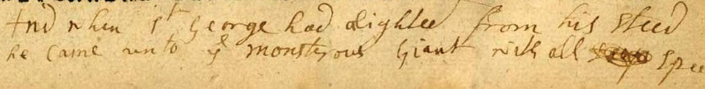

Handwriting in the margins of Page F in “Richard Johnson’s” *The Famous History of the Seven Champions of Christendom, The Second Part*.

1. Hilton Kelliher and Katherine Duncan-Jones, “A Manuscript of Poems by Robert Sidney: Some Early Impressions”, *British Library Journal*, 107-44.